Component 2 - Zoella and Online Media
Booklet – Darren Borg

Use of Media Language
Representation
Industry
Audience

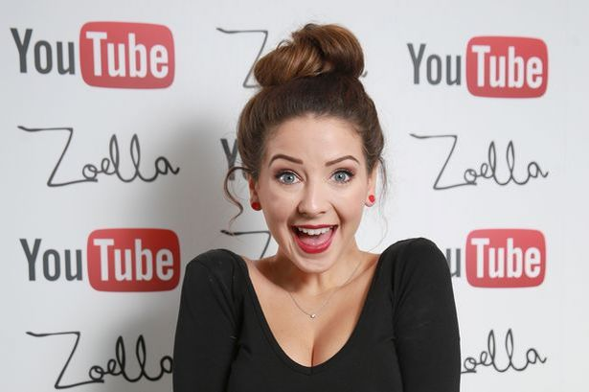

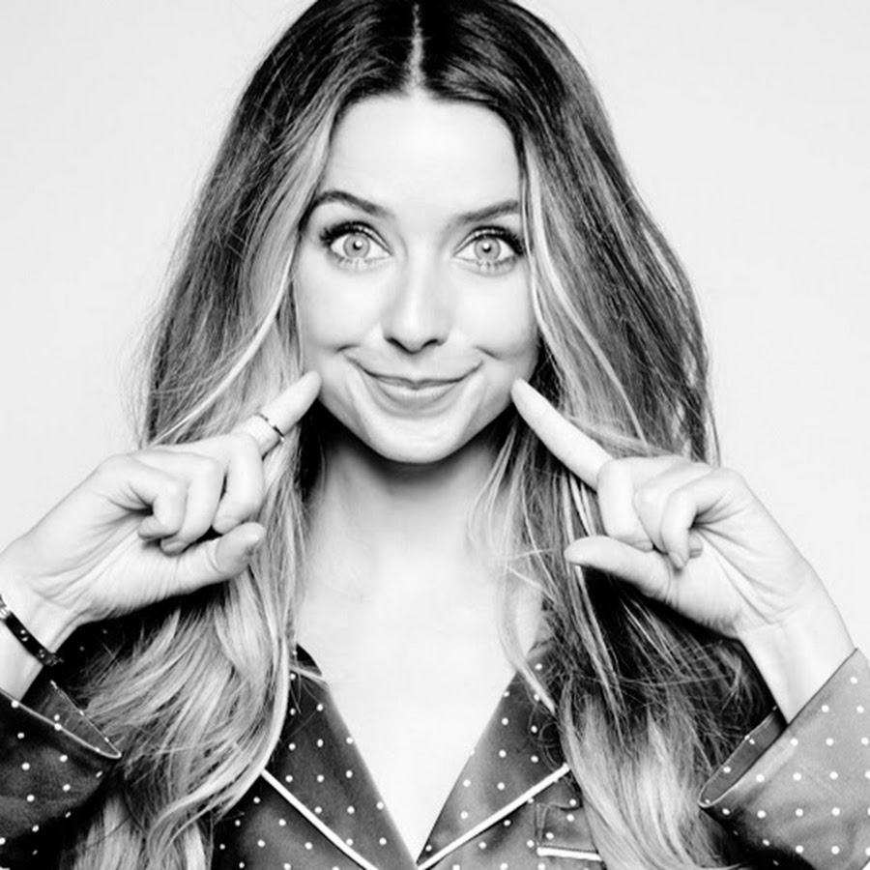

Full name: Zoe Elizabeth Sugg
Age: 28
She was working as an apprentice at an interior design company when she created her first blog, "Zoella", in February 2009
The fashion, beauty and lifestyle blog expanded into a YouTube channel in 2009, while she was working for British clothing retailer New Look
She was named as one of the National Citizen Service’s ambassadors in 2013, helping to promote the newly launched youth service. The following year she was named as the first "Digital Ambassador" for Mind, the mental health charity
Her main channel, Zoella, is mostly fashion, beauty hauls, and "favourites" videos (showing her favourite products of the previous month). Her second channel, MoreZoella, contains mostly vlogs where she shows her viewers what she does in her day.
YouTube subscribers – in excess of 11 million
Partner is Alfie Deyes, creator of PointlessBlog
She is the named author of three novels, aimed at a young audience and detailing the life of a fictitious female blogger, although she works with an editorial team and a ‘ghost-writer’ through her publisher, Penguin Books
She launched a range of beauty products under the brand name Zoella Beauty in September 2014

ACTIVITY
Watch the first ten minutes of the ‘Rise of the Superstar Vloggers’ documentary (BBC 4) https://www.youtube.com/watch?v=h_rn1h_tCaQ)

What has vlogging revolutionised?
People can share with many people, it has revolutionised the internet and YouTube platforms.

What is there a tendency to do?
Turn around the camera on themselves and film their everyday lives

What has vlogging given birth’ to?
A new breed of celebrity, a relatable content creator which the audience can see relatability to.

What does this mean for old media establishments?
For old media establishments it means that it doesn’t necessarily mean you have to spend masses amounts of money

What does the video say about the fan bases of some vloggers?
They sell out stadiums for their tours

Who do some influential vloggers have connections with?
Some influential vloggers have connections with eachother and celebrities

What sort of phenomenon is it?

What does vlogger Jim Chapman have to say about the ‘social’ aspect of vlogging?
That there are dark aspects to vlogging as well as consequences. Media outlets brand vloggers as ‘vain’.

What does Dr Ellen Helsper have to say about telling stories?
To be relatable to the audience, telling and sharing stories

When was YouTube launched? With what sort of technology?
YouTube was launched in February 2005.

When did YouTube introduce adverts on its site? What do these provide for some vloggers?
4 years after the release of YouTube, it introduced adverts. Meaning that vloggers can earn money

What does YouTube have the ability to do for some vloggers?
It has the ability to provide everyday people with content and can throw vloggers into the spotlight. Vloggers do meet and greets, books and merchandise inspired by their content.

READ
Read through the article and note down your responses below to the following questions
“Girl Online: What Zoella has taught us about successful influencer marketing. (Johanna Jones - www.thedrum.com)
Since Zoella started her first YouTube channel in 2009, she has amassed over 664m views, 11m subscribers, and helped propel the rise of what we now know as 'influencer marketing'. And this week, she added to that list of achievements with the launch of her third book: 'Girl Online: Going Solo'.
The ordinariness and relatability of Zoella is what has made her so appealing to fans who trust her advice and follow her every recommendation on beauty and fashion. It is precisely their sense of authenticity that fans attach to them that make influencers so attractive to brands who are looking to engage their target audience through the earned influence of celebrities like Zoella.
While the digital world is in a state of constant change, little has evolved when it comes to who we trust when pushing our on or offline shopping cart. In study after study, year after year, the people we know and those just like us online — are who we trust when making purchase decisions.
We have identified three types of influencers:
- Celebrities, or those paid to endorse a product
- Category Influencers, usually paid to share their expertise in a category to online followers
- Everyday Influencers, people in every part of the community surrounding you in-person and online
All types of influencers are important, and each plays a unique role in a brand marketing strategy. There is no doubt that celebrities and YouTubers with millions of followers offer brands an unprecedented reach and awareness, but the effectiveness of influencer tactics depends directly on the degree of authenticity. Consumers can easily sniff out contrived posts or inauthentic content.
Zoella herself is no stranger to the backlash over seeming disingenuous, as when it was revealed that her first novel, Girl Online, used a ghostwriter. Even though the book was still a financial success, many Zoella fans felt that they had been duped by the star. This is just one instance in which celebrities and influencers have faced backlash from fans after not disclosing they had been paid to promote particular brands or products.
Trust is the most important factor in purchases decisions. Every study has proven that, but it’s also common sense. Would you trust a product review from a celebrity or anyone paid for a review over a friend? Or someone you don’t know, who’s like you and shares your interests? Trust drives results. Of the three types, everyday influencers will be the trust winners every time.
So what can brands do to capitalise on the unique intersection of video and everyday influencers?
Brands need to join the conversation that their consumers are having on and off-line with their friends and families. The true, authentic content that is moving the dial for big brands is not content created by them, but by their consumers, authentic every day real people, who are creating and sharing entertaining, branded experiences with their friends. This person-to-person media is the most trusted form of advertising a brand can and should participate in.

Answer the following questions based on the article
When did Zoella start her first You Tube channel?
2009

Locate her You Tube channel and note down how many subscribers she currently has
11 million subscribers, 664m views

What makes her appealing to fans?
The reliability of vlogging their everyday lives makes it appealing to fans. It makes it relatable for them to be promoting from their own spaces.

According to the article, who are the three types of influencers?
1. Celebrities ot those paid to endorse the product

2. Category Influencers, usually paid to share their expertise in a category to online followers

3. Everyday influencers, people in every part of the community surrounding you in-person and online

What might the effectiveness of an influencer depend on?
The effectiveness of influencer tactics depends directly on the degree of authenticity. Consumers can easily sniff out contrived posts or inauthentic content.

Are influencers paid to promote particular brands or products?
Influencers mainly get paid to promote products, whether it is money or the product itself

What is the most important factor in purchase decisions?
The most important factor in making you buy it is the influencer recommending the product and showing its results. That the influencers represent the brand so negative attention reflects the brand too.

Who is creating most of the online content for big brands?
Influencers

ACTIVITY

Read the article from The Guardian ‘Why are YouTube stars so popular?’ https://www.theguardian.com/technology/2016/feb/03/why-youtube-stars-popular-zoella) and answer the following questions:
What were the results of the two polls conducted by Variety magazine in 2014 and 2015?
There were more than 17,000 YouTube channels with more than 100,000 subscribers. Nearly 1,500 with more than 1 million

According to the 2014 survey what might account for the popularity of YouTubers?
That they aren’t just popular, they are genuinely influential figures to their fans

What did the 2015 Variety magazine survey suggest regarding the emotional attachment to YouTubers?
YouTubers have now been categorised as celebrities- being ranked more influential than celebrities such as Bruno Mars and Taylor Swift.

What is the name given to the generation of young people (or those associated with vlogging from an older generation), associated with YouTube activity?
Millennials

In your own words, briefly highlight the summary points at the end of the article
It is interesting to perceive from an old industry perspective that the Newspaper Company is trying to understand why it is so popular.

MEDIA LANGUAGE
In recent years there has been a cultural shift towards user interaction through participation, connection and collaboration. This characterises the WEB 2.0 era.
Digital technologies and the growth of the internet has drastically altered the media landscape
Online media texts, such as blogs, file-sharing sites (such as YouTube), social media (I,e, Facebook, Instagram, Twitter etc.) is challenging the traditional relationship between producers, products and audiences
The cultural significance of content creators, such as Zoella, is measured in terms of subscribers to blogs and vlogs, and circulation of images in the mass media and mainstream culture

Activity
Compare Zoella’s blog homepage (https://www.zoella.co.uk/) with Tanya Burr’s blog homepage (https://www.tanyaburr.co.uk/)
Note similarities in the following:

CONTENT LAYOUT DESIGN
- Links and pictures to other social media- Instagram
- Simple, small colour scheme layout
- Content- Lifestyle. Both bloggers show travelling and their personal lives

Consider similarities with use of
FONT PHOTO IMAGES COLOUR
- Fancy use of font- girly colour schemes and themes
- Both blogs are image heavy- rely on imagery

Activity
What might the customised banner and logo of Zoella’s blog suggest about her and her audience?
The colour scheme of the logo suggest that it is personalised in the handwritten font. She uses her logo with her YouTube channel.

She also has a logo associated with her blog, a simple “Z” suggests that she is recognisable with her blog and her brand identity. The minimalist font of the logo shows the simplicity of the site

Activity
Consider the quality of photographs and how they might fit with the messages of her brand

The photographs are of high quality which is associated with a more ‘quirky’ aesthetic. The photos reflect the themes of the articles giving it a more thought-out approach and detail.

Activity
Choose two of the links on the blog (i.e. Beauty, Life, Style etc.) and then choose a story from each one.
What might be the mode of address? You should be looking at style of speech and level of information. Is the language formal or informal?
Link One: https://zoella.co.uk/2020/03/12/styling-corners-of-your-home-for-spring/
The mode of address shows that the style of speech is a mixture between formal and informal as it implements different styles and tones in order for the audience to feel a sense of characteristics that Zoella exhibits

Activity
Analyse the layout of Zoella’s YouTube channel (https://www.youtube.com/user/zoella280390) and compare it with her blog – are similar conventions used to tie the two together?
The thumbnails of her YouTube channel use a quirky theme likewise with the images on her blog. There is also a different logo used on the banner of her YouTube channel.

Activity
On her YouTube channel https://www.youtube.com/user/zoella280390) watch a few minutes of three videos of your choice – note the significance of SETTINGS and the connotations of them
The videos are set within a home environment- implementing the theme of relating to the audience. It has a theme of plants and a plain background, often with led lights. The backgrounds also reflect the time of year- Halloween themed-autumn, Easter-Spring colours.

What can you see in SHOT (mise en scene)?
In the mise en scene you can see the set up- this also changes depending on the theme of the video- Making Easter themed cupcakes are in the kitchen. Whilst makeup themed videos are typically in a bedroom environment. This shows that the theme of the video changes the setting and therefore reflects the reliability aspect. She also does themed videos such as Question and Answer sessions which makes her relate her more.

What MESSAGES and MEANINGS might be conveyed by these videos?

Non-verbal communications and body language – what connotations might we get from FACIAL EXPRESSIONS, GESTURES and DRESS CODES within the videos? How do these help to construct Zoella’s identity/persona?

There is a sense of positivity to the videos with the use of lighthearted background music. They exaggerate the situation through excitement displayed within the video.

ACTIVTY
WATCH the first fifteen minutes of (https://www.youtube.com/watch?v=dB-RqoR_MCI) ‘Time Out in a Treehouse’ and identify how the following elements have been featured. You can use the ‘Engaging Audiences Glossary of Terms on pages 33-34 to help you with this task
Use of everyday mise en scene (locations, lighting, costume, props)

Codes of realism (camera, sound, mode of address)

Breaking the Fourth Wall (direct address to viewer)

Amateur aesthetic (use of camera, presenting style)

Ideal imagery (imagery depicting escapist values)

Unscripted narrative (sense of everyday realism)

Aspirational narrative (inspires audience to want a particular lifestyle)

Best friend characterization (how Zoella speaks to the audience as an ‘individual’ friend)

REPRESENTATION
Key Theorists – DAVID GAUNTLETT and STUART HALL

David Gauntlett’s theory of IDENTITY
Suggests that we, the audience, draw upon media representations when constructing ourselves.
The relatively new age of online media offers a wide variety of resources to draw upon, in Gauntlett’s words “an open realm of possibilities” (Gauntlett, 2008).
This would suggest that the plurality (meaning ‘many’) and diversity of online media representations gives us more choice of how we create and communicate who we are.
Gauntlett also suggests that the media provides resources in the form of ‘stories’:
“We use these narratives to frame our experiences and to bring order to the stream of ‘stuff’ that goes on in our lives” (Gauntlett, 2008
This ties in with the function and appeal of blogs and vlogs. Zoella provides her fans with a means of imposing ‘order’ and ‘meaning’ on the stuff they experience in their own lives.

Activity
Look through the comments on some of Zoella’s videos on her YouTube channel or postings on her official Instagram page (https://www.instagram.com/zoesugg/?hl=en) and see how they might reflect Gauntlett’s quote regarding ‘order’ and ‘meaning’

Stuart Hall’s theory of REPRESENTATION
A key quote attributed to Hall is “Representation is the production of meaning through language (which include) signs and symbols, whether they are sounds, written words, electronically produced images…to stand for or represent to other people our concepts, ideas, feelings ” (Hall,2013)

ACTIVITY
What kind of lifestyle is Zoella representing through her blog and vlogs?

How do the ‘stories’, images and videos demonstrate this?

Self-representation
Through the quickly expanding technologies of the internet and mobile devices, we can construct our own representation(s) which may either accurately reflect us or shows the world which ‘stories’ we want them to see. This would have been almost impossible twenty years ago, but is now common-place, and on a global scale.

Activity
Consider your own representation online:
Which social media do you use?

Which do you use most frequently?

Do you ‘filter’ what you show? (i.e. choose only specific information, adapt your appearance in photos etc.)

Do you follow anyone in particular (apart from friends and family) and why?

If you were to produce a blog or vlog, what might it be about? What are your specific interests?

Zoella’s self-representation is seen as ‘authentic’ but has also been carefully manipulated and constructed. She has chosen specially what to disclose and share and what to withhold (bear in mind she has gone ‘public’ regarding her mental health issues)
In media terms this is referred to as a ‘gatekeeping’ function
Gatekeeper – definition
A person or organisation that is involved in filtering content in some way, similar to the process by which news stories are chosen by news editors.

Representation of Gender
For this area of representation we should consider aspects of social identity within the production and reception of blogs and vlogs

Activities
To what extent does Zoella’s blog and YouTube channels reinforce gender stereotypes? Consider the use of ‘stories’, colours, typeface and design.

Is there a gender-specific mode of address?

Which topics and interests does she cover on her ‘More Zoella’ YouTube channel, and are they gender-specific?

Representation of Gender (continued)
Zoella’s blogs and vlogs have a similar construction of gender to that of teenage girl magazines – and could be seen as a direct replacement.

Gender reinforcement can be seen through the promotion of particular products and brands – Zoella’s channel is financed by the beauty industry through sponsorship and deals.

GENRE CONVENTIONS OF VLOGGING
Read through the article Vlogging conventions discussion – the construction of everyday celebrity superstars ( http://resource.download.wjec.co.uk.s3.amazonaws.com/vtc/2017-18/17-18_3-22/pdf/unit01/2-vlogging-conventions-discussion-printable.pdf ) and answer the following questions:

In paragraph 1, what ideals do traditional conventional advertising contain and what ideals does the vlogging community contain?

In paragraph 2, describe the conventions of producing vlogs

In paragraph 3, use bullet points to highlight the terms printed in bold

Who might be the potential secondary audience identified in paragraph 4, and briefly why?

How might vloggers like Zoella maintain their commercial success in paragraph 5?

In paragraph 6, how might the intended audience be seen as ‘active’?

In paragraph 7, which other online sites can prove useful to a vlogger to widen their potential audience and reach?

In paragraph 8, what is the term used to describe vloggers?

Again in paragraph 8, what is the method called to engage new fans?

And again in paragraph 8, what is the term for promoting particular brands or products?

In paragraph 9, how many collaborative vlogs does Zoella create each month?

Also in paragraph 9, describe what the term ‘collaborative content’ means

Finally, in paragraph 10, what issues might arise when a vlogger becomes too popular and established?

INDUSTRY
Impact of recent technological change
Important to understand that recent technological change has made the creation and distribution of online media more democratic; meaning that the general public can create and distribute their own product without the need for professional organisational involvement (apart from the availability of software and hardware).
This has also changed the way in which media content is made public without a ‘gatekeeper’ to allow what gets seen or not. A vlogger can simply produce and distribute a video, via a file sharing site, by means of a mobile phone, digital video camera or webcam and access to the internet.
This has led to the huge growth in user-generated content over the past ten years, demonstrating that anyone can produce media, regardless of content or quality.
User-generated content – material created by everyday users of media platforms rather than professionals working for media organisations. Some media organisations do put out requests for content produced by fans as a way of increasing their content and building a relationship with fans.

Economic context of the Online Media Industry
Channels or vlogs with a large number of subscribers, such as Zoella’s, can be economically lucrative due to the amount of web traffic generated. This allows multi-channel networks (MCNs) – organisations which look after high-volume content creators regarding marketing, promoting and monetising their channels in return for a percentage of the creator’s advertising revenue (this is where the BIG money is!).
Monetisation – the process through which a product or service – such as a blog or vlog – is converted into a source of commercial revenue. YouTube has recently put heavy restrictions on content creators who can only claim revenue through the YouTube partner Programme if they have a total watch time of 4,000 hours in the past 12 months and a minimum of 1,000 subscribers.
It is worth noting that YouTube has been owned by Google since 2006 (bought for $1.65 billion), so advertising goes through GoogleAds, thus generating more potential revenue and access.

Advertising
The YouTube Partner Programme enables creators who have achieved a total watch time of 4,000 hours in the past 12 months and a minimum of 1,000 subscribers to generate money through their content by running ads alongside. This is then shared between YouTube and the creator.
The ads can be displayed as banners at the top or side of the homepage, overlay ads which sre placed on top of a video and can be clicked off, or video ads which can appear before, during or after the video (a non-clickable six second video ad is called a bumper ad)
Relevant adverting is often targeted to match tastes, interests and browsing history of users. These are frequently matched by the use of algorithms.

Activity
Use the three websites listed (YouTube https://socialblade.com/youtube/user/zoella280390) , (Instagram https://socialblade.com/instagram/user/zoella ) and Twitter https://socialblade.com/twitter/user/zoella) to gauge how big Zoella’s profile is with regards her social media platforms. This should inform you as to her potential for advertising and sponsorship (see next section)

Sponsorship
Along with advertising, sponsorship is another important source of revenue.
Content creators are paid to review. Endorse or promote particular products or brands.
The endorsement of digital influencers, like Zoella, can have a significant effect on sales, encouraging companies to pay bloggers and vloggers substantial sums of money.

Merchandising and Diversification
Zoella has various merchandise which sells both online and in physical retail, including her own range of beauty products and fragrance, and ‘lifestyle’ products aligned to her fan base (such as phone cases, stationary, journals, diaries etc.)
This is part of the brand recognition process, which would include familiar icons such as her image, logo and slogan.
The publishing of her four ‘ghost-written’ novels also act as a form of synergy as these can also promote her blog/vlog and vice versa. Downloadable apps also act as synergy, linking all the different platforms and outlets.
The key to all this is digital convergence whereby her visibility is extended to a wide variety of digital platforms which can all be linked together.

Regulating Online Media
Due to the vast amount of websites, blogs and videos posted every day, actively regulating and controlling this it is a major challenge. This is mostly down to the wide variety of different sources and platforms.
There is also much debate regarding who should be responsible for monitoring and controlling this output, dividing responsibility between the Internet Service Providers (ISPs), social platform companies such as Twitter or Facebook, or a government department.
Advertisements which may appear on Zoella’s various social media platforms, such as her blog or YouTube channel, must comply with a certain standard code as outlined by the Committee of Advertising Practice (CAP); this prevents the audience from being misled over products.
Zoella (and all other bloggers and vloggers must comply with Consumer Protection laws through the Office of Fair Trading (OFT). This law means that Zoella must declare any sponsorships, affiliations or promotions, so as again not to mislead her audience.

YouTube ‘Community Guidelines’
There are various restrictions which are imposed by YouTube https://www.youtube.com/intl/en-GB/yt/about/policies/#community-guidelines to prevent issues such as nudity, violent content and copyright infringements.
These guidelines are intended to make YouTube both a user-friendly environment and also an advertiser-friendly environment, too. Content users, such as Zoella, are encouraged to produce suitable content for all ages, and therefore advertiser-friendly; any that do not comply with this will not be legible for monetisation. In this way commercial (Zoella’s brand and her sponsorship deals) and economic (the amount of money which can be made) can shape and influence media content.

AUDIENCE
We have established that Zoella’s key target audience might be teenage girls between the ages of 13 and 17, we should consider how this audience is targeted through the content and appeal of the online media product she produces
Equally we should consider how this audience is targeted through the ways in which online media products are marketed, distributed and circulated.
Some of this can be identified through the ‘modes of addresses used to ‘sell’ her lifestyle message. This is sometimes referred to as ‘para-social interaction’
Para-social interaction – the direct mode of address used by Zoella creates the illusion of personal, face to face communication. She uses a friendly, conversational mode of address when talking to her fans, helping to create a sense of intimacy, even though she is potentially talking to over 12 million subscribers.

Collaboration videos
Zoella sometimes appears in videos with other vloggers, such as Tanya Burr or her partner, Alfie Deyes. These collaborations help to broaden her fan base and potentially reach a wider audience.
These can be divided into two separate videos or divide it into two parts. One video can be uploaded onto the channel of Zoella and one to Tanya’s, for example. This means that the viewer must go to each website to access the whole video.
A collaboration video often ends in a call to action as viewers are encouraged to subscribe to the channel of each creator. A link is often found in the description box of each upload to aid navigation between the channels.
Call to action – an instruction that is issued to the audience with the aim of prompting an immediate response, such as ‘subscribe now’, or ‘click this link’. This type of method is regularly used in marketing and advertising.

Festivals, Conferences and Conventions
Big-name vloggers are often promoted through festivals, conferences and conventions, with events such as VidCon extremely popular in the United States, Europe and Australia. Here, vloggers can network with others in the online media industry, but fans also have the opportunity to meet them in person. These meetings are often built around ‘Question and Answer’ (Q&A) sessions, personal signings and meet-and-greet opportunities.

Public Appearances
High profile vloggers such as Zoella, Tanya Burr and Alfie Deyes are often invited to awards ceremonies for a variety media industries and film premieres. This works for both parties as it provides a sense of ‘cutting edge’ for the organisers to have the ‘latest thing’ appear for their event, and for the vloggers to raise their profile by appearing in the mainstream media
These events also allow vloggers to meet their fans, albeit on a very brief basis, often restricted to some selfie opportunities.
Both Zoella and Alfie have frequently appeared on the covers of magazines targeted at the same audience demographic. A selection can be found below:

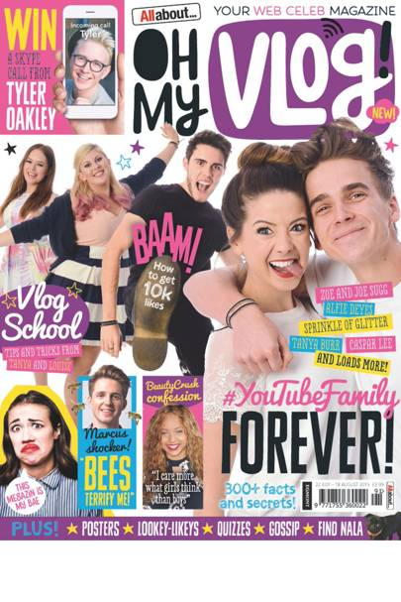
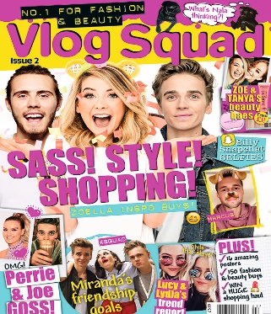
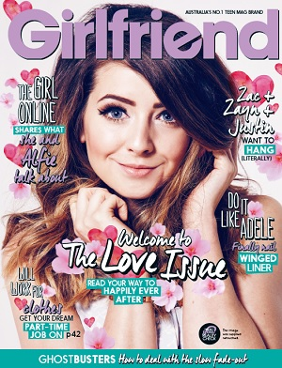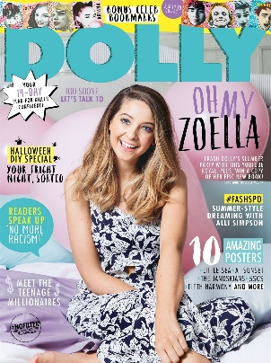

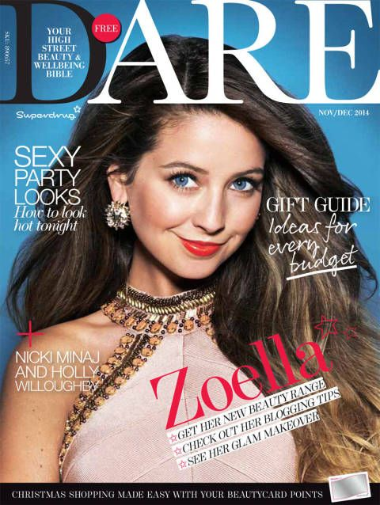
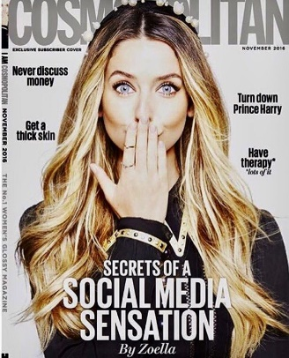
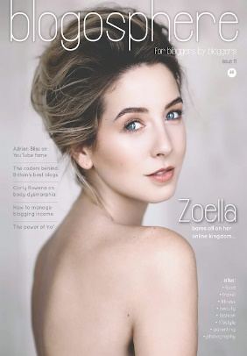
In more recent years, she has appeared on magazine covers aimed at an older audience, reflected her social position, growing maturity and able to reach a different audience:
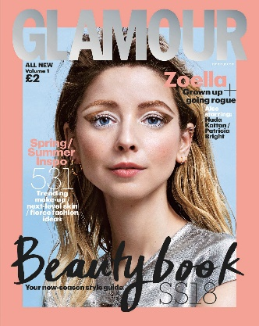

Audience Participation and Interaction
Much of Zoella’s success depends on how ‘accessible’ her fans and subscribers find her to be. Being able to leave comments on her YouTube videos, blog posts, Tweets, or on occasions providing content for her sites.
She does ask her fans for opinions on what they might like to see in future videos or blog posts, and in doing so her audience feels ‘active’ and that the relationship goes two ways. The emergence of quicker, faster and sophisticated online and mobile technology allows for this important interrelationship between content creators and digital influencers like Zoella and the fan base.
This demonstrates how Zoella’s audience can interact with her online media products and platforms, but also how they are considered as ‘active’. It shows the interrelationship between media technologies and how these are consumed by her audience and allows for response.

George Gerbner’s Cultivation Theory
An important aspect to consider regarding Zoella’s audience is how their own values, attitudes and beliefs might be shaped by viewing or interacting with her online products.
Gerbner’s theory is very important to attach to the study of Zoella, not only with her online products, but her wider influence on her audience and how this might manifest itself.
Gerbner states that repeated or prolonged exposure to any form of media will influence the audience to follow or replicate the messages, values and attitudes of the media text. In terms of Zoella this might be related to the amount of time any one of her subscribers spends online and the level of engagement – for example, does someone follow her through all her media platforms and affect their day-to-day experiences. This might relate to buying the products she promotes or is affiliated to, or at the extreme, to live their own lives through constant engagement with hers.
This can be seen through Gerbner’s theory relating to ‘resonance’. This would refer to how a Zoella media text matches the everyday reality of the individual’s own life. And possibly shape their view of the world.

Activity
Consider the comments left on examples of Zoella’s YouTube videos, Instagram posts or Tweets to see if these have affected her fans with regards to attitudes, beliefs or values. These could relate to the products she demonstrates, her celebrity lifestyle, or on a more personal level, her involvement with mental health.

ONLINE MEDIA – GLOSSARY OF TERMS

TECHNIQUE | DEFINITION | EFFECT ON AUDIENCE/REASON FOR USE
High image to text ratio | Using layouts that are dominated by imagery | Deployed on landing pages to make webzines look visually exciting and to minimise reading time
Lede intro | The first paragraph of a news story that usually gives a summary of the whole story | Provides the who, what, where and when of a story – creates an active feel
White space | Space used to layout text in order to make it look inviting on screen | Makes reading text on screen easier by chunking text
Teaser headlines | A headline that uses a question | Acts as clickbait, driving audiences to view additional text to find answers to the question posed
List article | An article structured using a listed narrative. Examples might include: ‘Zoella’s Top Ten Make-Up Tips’ or ‘Ten Films You Must See in 2019’ | A type of article that can be scan read – ideal for web layouts where long read articles are off-putting
Emotive language | Using verbs and descriptors that have strong connotations | Helps stories create an emotional response through language
Foregrounded advertising | Placing adverts or sponsored content in prominent places so audiences will notice them quickly | Helps webzines sell advertising space by placing ad material in prominent positions
Wraparound advertising | Adverts that feature in the side columns of web pages | Increases advert visibility and allows webzines to monetise dead spaces on web pages
Sponsored content/advertorials | News articles that promote a service or product and are paid for by advertisers | Generates more impact than conventional advertising – tries to make ads look like a news story with journalistic integrity
Light editorial mix | An editorial mix refers to the range of stories in a magazine or webzine – editors spend lots of time making sure their EM is appropriate | A range of stories that usually feature entertainment, fashion and culture based content to create an escapist feel
Salacious content | Stories concerned with gossip or scandal | Gossip or scandalous content appeals to the voyeuristic instincts of audiences
Syndicated content | Pooled story content shared by media producers from around the world | Helps media producers create global stories without having to station lots of reporters in different countries
Star power | Stories that use celebrity content to gain interest | Creates an aspirational dynamic – celebrity content also creates escapism
Backgrounded content | Placing essential institutional information (contact details, dates, terms and conditions) in less prominent positions | Helps create audience engagement quickly by making less important information less visible
Tagged content | Grouping stories under searchable titles | Helps readers search for content on webzines or social media
Search engine optimisation | The process of making sure that webzine pages achieve high search engine rankings – usually achieved through careful use of keywords | Helps webzines attract new readers – high search engine rankings also give websites authority and helps them sell advertising space
Social media optimisation | The process of making sure content stands out on Twitter, Instagram and Facebook user feeds – SMO requires carefully applied language and imagery to create audience engagement and to develop the brand identity of a product | Makes sure content has visibility on Twitter, Instagram and Facebook user feeds

ENGAGING AUDIENCES – GLOSSARY OF TERMS

TECHNIQUE | DEFINITION | EFFECT ON AUDIENCE
Jump cut | An editing technique that cuts material from single takes, giving the effect of jumping forward in time | Creates narrative energy by missing less important parts out of a final edit and is also suggestive of an amateur aesthetic
Breaking the fourth wall | Where the presenter addresses the audience directly | Creates a personal connection with the audience by speaking to them directly
Unscripted narrative | Improvised moments in narrator dialogue | Suggests spontaneity and authenticity – mirrors, to some extent, real life conversations
Collaborative content | Where vloggers make co-productions | Helps construct an imagined community and allows vloggers to market themselves to each other’s fan bases
Amateur aesthetic | A deliberately non-professional filming style | A lack of professionalism helps vloggers generate an unmediated feel to their products. Suggests authenticity
Everyday mise-en-scène | Using costume, make-up and sets that appear natural | Creates a sense of the everyday and suggests that audiences have access to the private world of vloggers
Presenter POV | Seeing what the presenter sees | Often achieved by temporarily rotating the camera to mirror the presenter’s perspective. Removes the barrier between audience and presenter
High-key lighting | A lighting style that eliminates shadows | A lack of shadow has connotations of a natural/happier tone
Invitation into private spaces | Filming that takes place in bedrooms, private houses, office spaces – places that are normally off limits to film crews | Enables the presenters to create trusted content and intimacy. Because filming takes place in the private worlds of vloggers, we think we are being given privileged access to their private thoughts
Narrative authenticity | Story structures that deal with real life – the intention to construct media that isn't mediated | Creates a sense that the vloggers are being honest – that their content is trustworthy
Best friend characterisation | A presenting style that gives the audience access to details of the presenter’s life | Makes the audience feel privileged, suggesting they have a personal relationship with the presenter
Confessional narrative | Giving the audience access to inner thoughts – also allowing the audience to experience inner doubts and worries | Makes presenters seem human/relatable – also constructs character fallibility
Candid imagery | Photographs that aren’t posed | Generates a natural and authentic mode of address through imagery – as if you’re looking at family snaps
Sanitised story content | Content that avoids controversy, taboo language or material that may cause offence | Allows for age appropriate content in vlogs – also allows vloggers to steer clear of demonetising algorithms
Single camera edit | A production filmed with just one camera – usually very quickly | Enables a quick production turnaround by a small crew – also helps construct an amateur aesthetic
Narrative currency | Stories that are updated – that discuss items that are up to date | Suggests that vloggers are working in real time, that their content is constantly updated
Codes of realism | Technical, narrative or symbolic devices that are suggestive of the real world | Creates relatable content – suggests that vloggers are part of the real world of the viewer
Aspirational narratives | Stories that inspire audiences to want a particular lifestyle or to change their behaviour in some way | Creates escapism, taps into an audience’s desire for an ideal lifestyle

Summary
Throughout our study of Zoella and online media you should now be familiar with the following concepts:
• The way in which digital technologies and the internet have changed the relationship between media producers, products and audiences in the Web 2.0 era
• The conventions of online products such as blogs and vlogs
• Issues regarding self-representation and the representation of social identity in blogs and vlogs
• The way in which online media products can be monetised through sponsorship and advertising
• The way in which bloggers and YouTubers target and attract audiences through the content and appeal of their products and through the marketing strategies they employ
• The way in which users interact with online media products

This knowledge MUST be applied to your understanding of Zoella for the exam

Essential theories to apply for Online Media
When discussing Zoella you MUST be able to use the following theories

Semiotic theory – including Barthes: for example, the idea that blogs and vlogs convey their meanings through a process of signification (or signs), such as use of fonts, colours, images etc.

Theories of Identity - including Gauntlett: for example, the ideas that online products provide users with an array of resources with which to construct their identities

Theories of Representation – including Hall: for example, the idea that online representations are constructed through media language

Cultivation theory – including Gerbner: for example, the idea that over time blogs and vlogs may come to shape and influence the way in which users see the world around them

