Roland Barthes’ Semiotic Theory: Riptide
SIGNFIER | DENOTATION | CONNOTATIONS
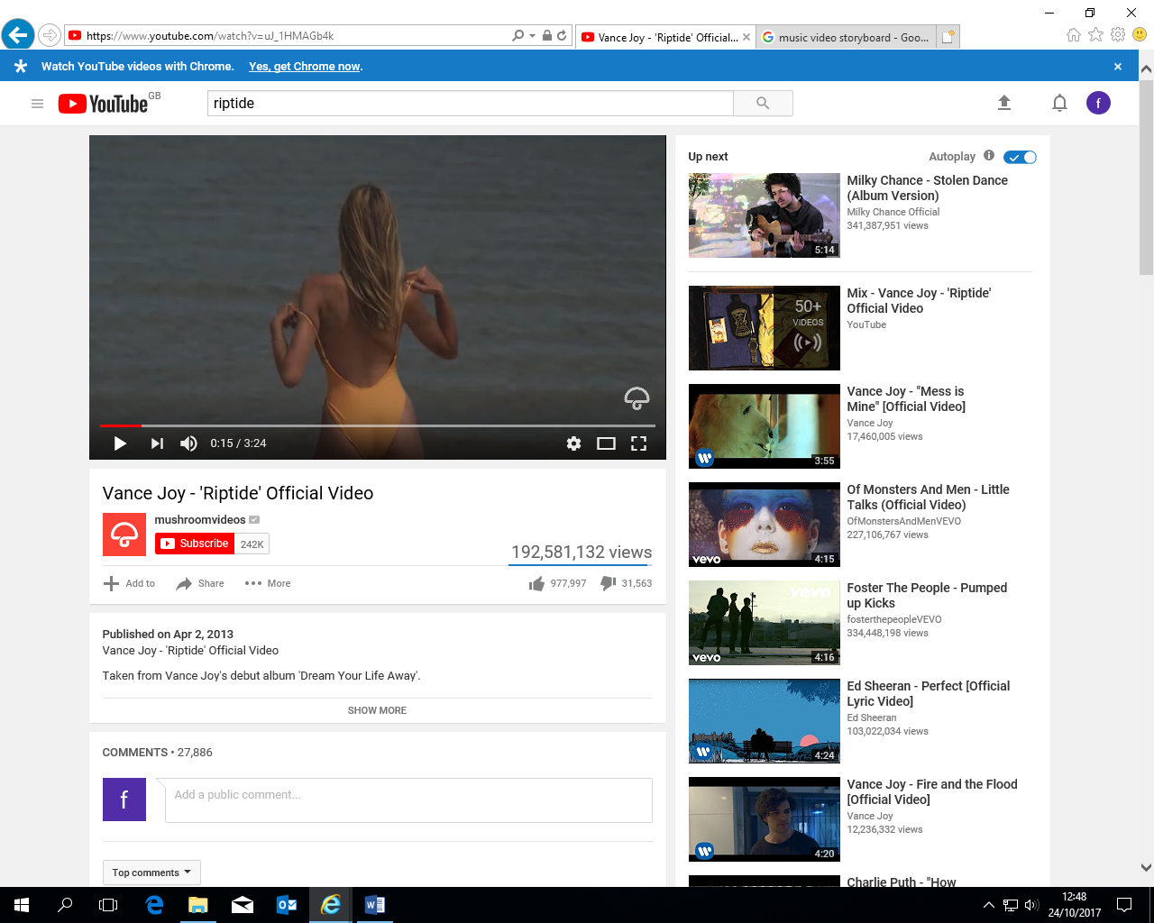  Lyrics: I was scared of pretty girls | Shows a girl at the beach taking her swimsuit off | Represents her being watched unsuspectingly, and implies she is the “pretty girl” that Vance Joy is referencing
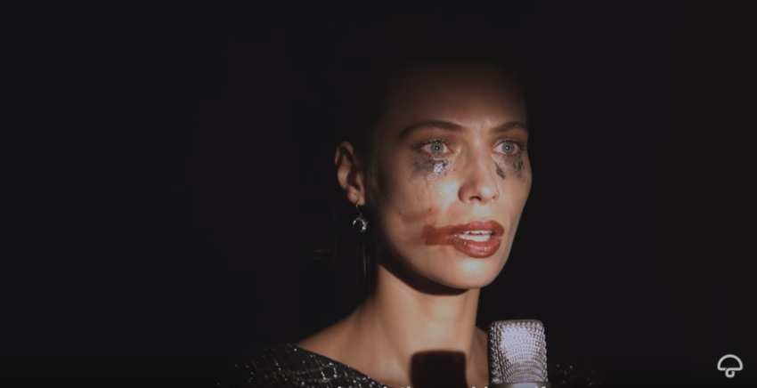  Lyrics: I love you when you singing that song and I got a lump in my throat cos you gonna sing the words wrong | Shows a woman looking distressed intentionally singing the words wrong to the song (cos you gonna sing the worlds wolf). | The makeup is shown to highlight that fact that she’s been crying and possibly abused. She is seen as glancing off to the side of the camera implying that the abuser is there watching her.
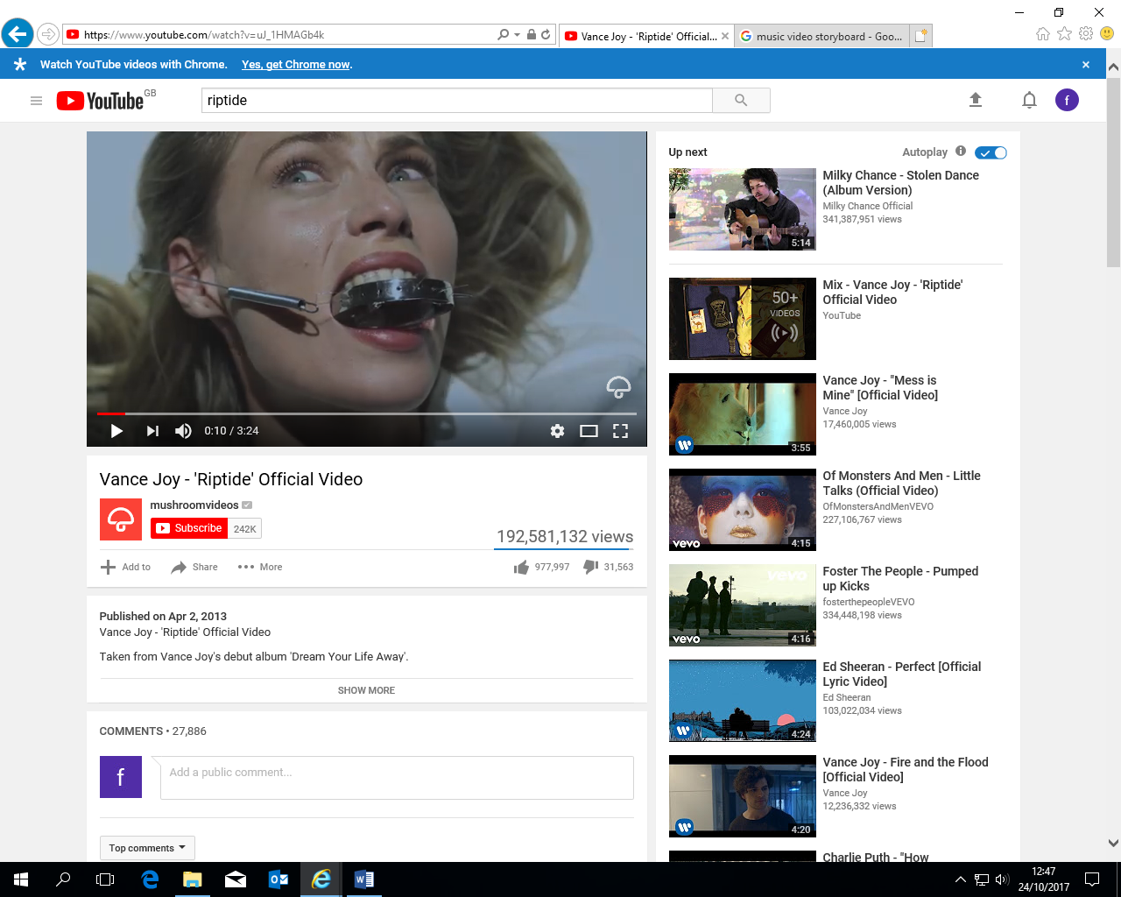  Lyrics: I was scared of dentists | A woman looking horrified being wheeled in to a dentists. | Perhaps a performance of some sort of physical constraint.
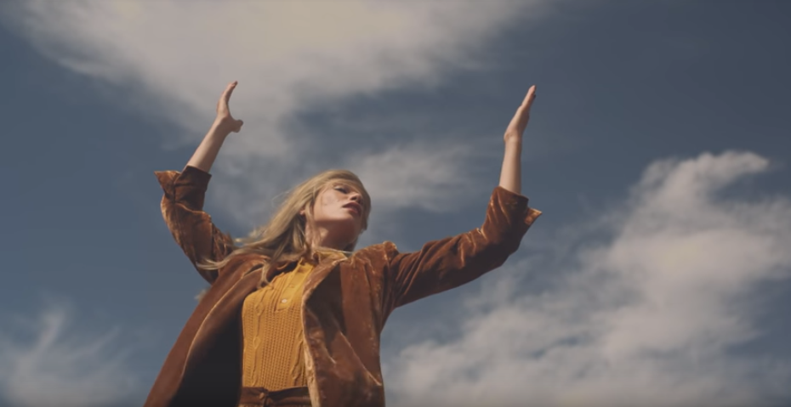  Lyrics: You're the magician's assistant in their dreams |  | She’s an attractive woman, and the shot is taken at a low angle to highlight her dominance and power.
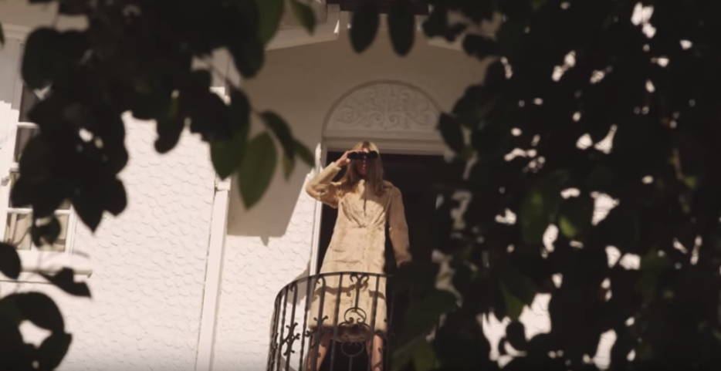  Lyrics: And she’s been living on a high shelf | A woman looking out from a balcony with binoculars. | She can be seen as searching, yet it is also clear that she is being spyed on by someone else that she cannot see.
  Lyrics: And they come unstuck | Depicts two lollipops being separated. | Possible metaphor for a couple separating
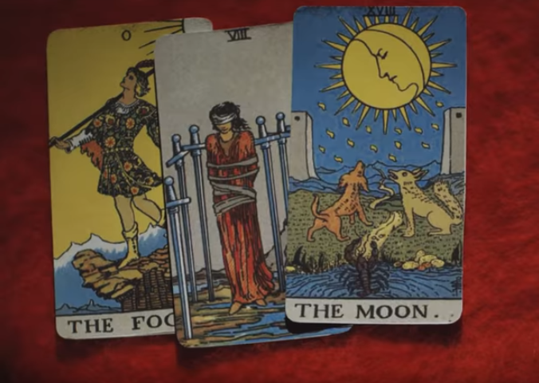  Lyrics: I just wanna, I just wanna know | Tarot cards being laid out | Someone is having their fortune read out, however it doesn’t look very pleasant. With the last card reading “the hanged man”- possible comment on male patriarchy?
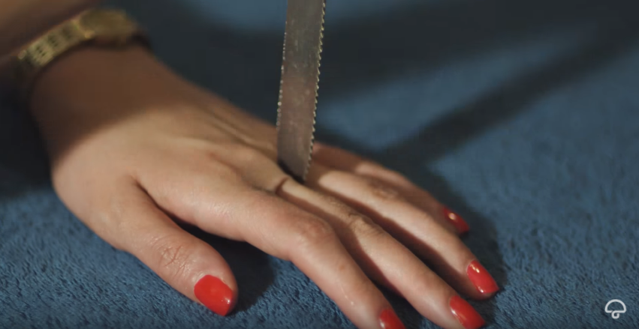  Lyrics: I wanna be your left hand man | A female hand being stabbed | Reference to a movie-scene (Un Chien Andalou) 1929
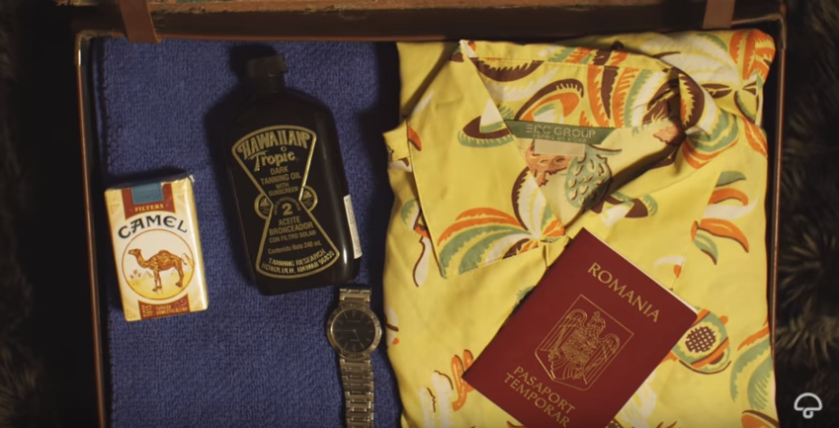  Lyrics: If you’re gonna, If you’re gonna stay | Someone packing a suitcase for a trip | Reference to a movie director Wes Anderson
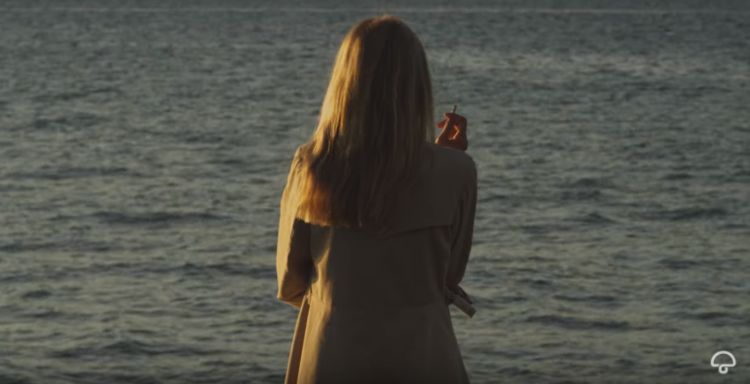  Lyrics: Closest thing to Michelle Pfeiffer that you've ever seen | Quick shot of a movie director and camera crew filming a woman looking out to the sea | Comment on the female figure constantly being watched by men in a position of power.

