Component One, Section A - Music Video - Beyoncé: Formation

Media Language Analysis

Media Language Analysis | Denotation | Connotation | Mise-en-scene (props, setting, costume, lighting, body language, facial expression) | Representation | Audience | Industry | Contexts | Theory that can be applied here.  CHALLENGE TASK
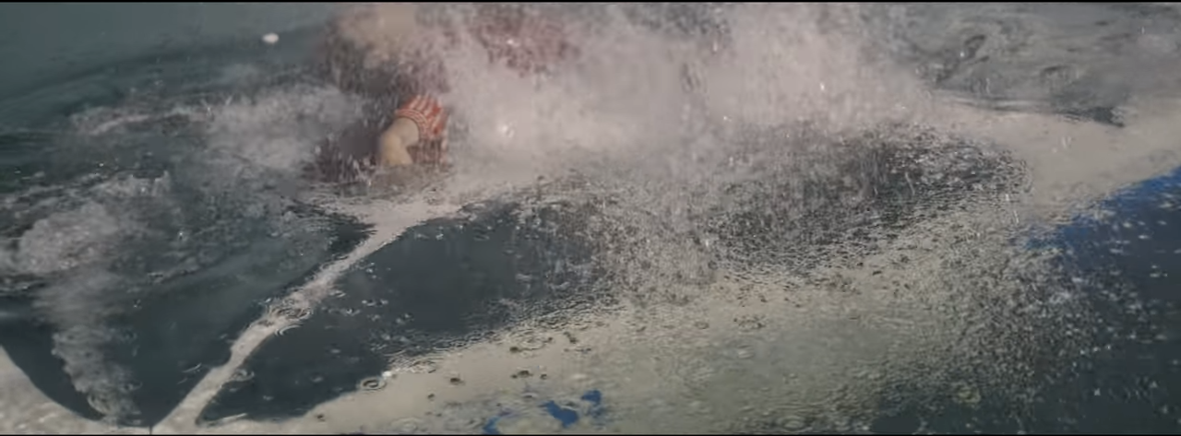  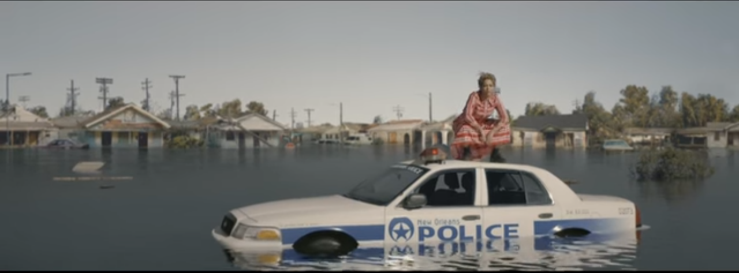 | Beyoncé sitting on top of a New Orleans police car with shots of flooded houses in the background at the start of the video and pushing the car under the water at the end. | Reflects the New Orleans floods of Hurricane Katrina in 2005, the response to the floods that resulted were criticised, with people feeling like the Federal Government were slow to meet the demands of the people that were displaced. | Includes a long shot of Beyonce with the car as it slowly sinks under the water. | Beyonce represents the police as incompetent as the police car sinks it connotes that they are insignificant and the everyday people are superior as she is above the car. | As Beyonce is American, a large part of her audience are likely to be Americans who remembers or experienced the floods. This might have made them feel empowered that she is calling out the response. Beyonce also started a Hurricane Katrina fund after the storm. | Symbolic to the industry in regards to African-American women being in a position of power above the police car, with Black Lives Matter in regards to police brutality. | 2005 Hurricane Katrina which devastated parts of Alabama, displacing hundreds of thousands of people.
0.28  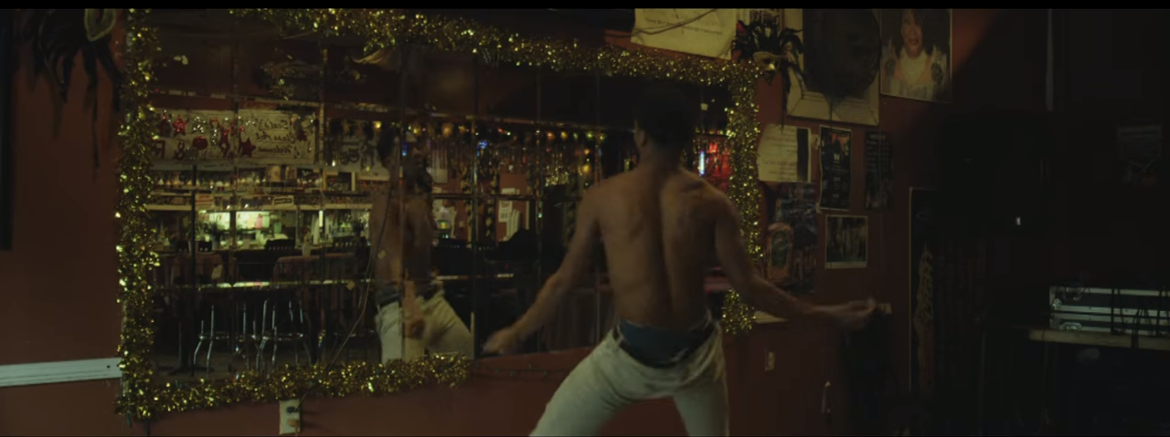 | Depicts a dancing man in an ancient corridor | Reflects the changes attitudes towards the LGBT community with the old style furniture reflecting this. | Low key lighting in the shot to highlight all the golden sets and expensive pieces reflecting status. | The representations of the LGBT community have changed over and societys views. This way of highlighting that there are still more improvements that can be made as not everyone has developed from the outdated opinions. | The audience would see this as a direct reference to the LGBT community and representing them alongside other oppressed minorities in the music videos. |  | Reference to the LGBT community with large movements the year before, with Colombia, Jamaica, Mozambique, Nepal and Taiwan making changes to laws to protect the gay community.
0.58  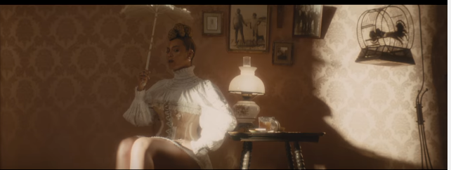 | Beyonce is sitting in an old style setting with her head not entirely facing the camera. | The clothing is from the slavery in America time period, which salve owners wives would typically wear. | The costume directly links to the time period in regards to slavery. The lighting is limited to make the scene look natural. Beyonce isn’t entirely facing the camera showing her superiority and power and how times have changed. | Beyonce is represented as superior as she has her face away from the camera. However she is also showing that times haven’t entirely changed by the lighting not touching her face. | The audience would see this reference to slavery as controversial, however she is showing the influence she has by being an African-American in a slavery costume. | The direct link to the Black Lives Matter campaign a year before the release to this video. | Links to Black Lives Matter and Slavery owners wives. | Gilroys Postcolonialism theory applies to this by the racial hierarchy
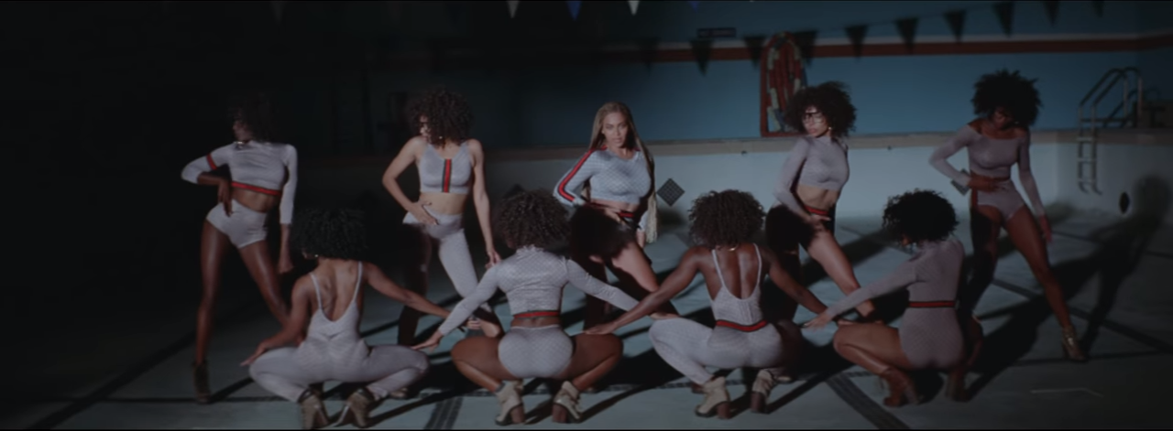 | 1.31 - Beyonce and her dancers performing in formation. Wearing stereotypically tight fitting outfits audiences expect in a Pop music video. | The genre of the music video is an approach to bounce music, contradicting the pop-culture style and an attempt to subvert from mainstream music videos. | Low key lighting in a pool just highlighting the dancers, the outfits are all the same style as well as the hairstyles being the same. | Representation of African-American women as underrepresented in mainstream media. Beyonce is attempting to make change in this video through the use of backup dancers who aren’t represented as inferior as they usually are due to them wearing the same outfits as Beyonce. | The audience would see this change between having all African-American backup dancers as different from mainstream pop music videos, Beyonce does this to highlight this underepresentation. |  | Stereotypical pop music videos of the time is extremely different from this genre of Bounce music, it shows the pointlessness of mainstream media.
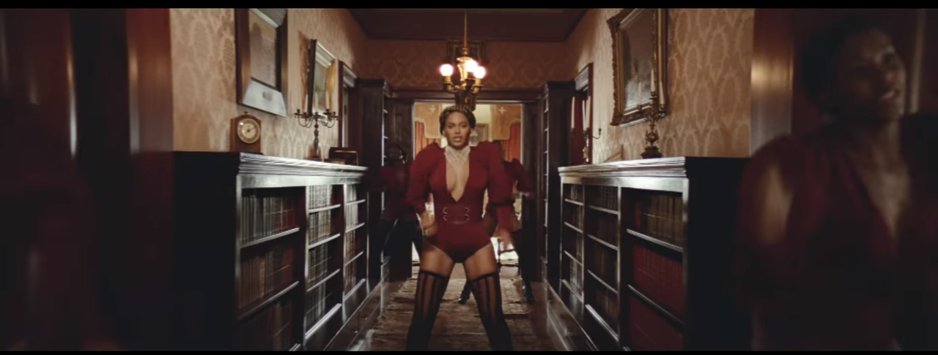 | 2.00 Beyonce is seen dancing in an old style hallway with backup dancers. | Beyonce is dancing with other African-American backup dancers contradicting the pop culture theme of whitewashing and slavery. | Directed lighting down the hallway, a narrow hallway filled with old-style furniture. | Beyonce represents her backup dancers down an ancient corridor. The wallpaper matches the shot before with Beyonce being sat in slavery-related clothing. | The audience would see this shot as reference to the previous shots as they are in the same setting style, referencing the change between time and race. |  | 2008= 8 years after the L’Oreal whitewashing scandal, where Beyonce’s picture was whitewashed for an advertisement.
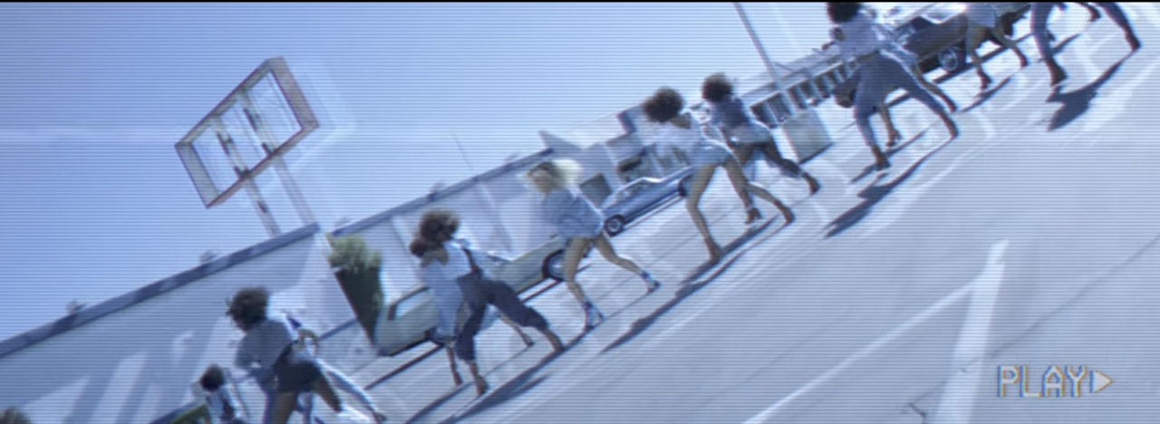 | 2.38 Multiple long shots of backup dancers in a car park | African-American backup dancers in a 90s pop music video style to highlight time period changes. With their natural hair nodding towards the critical responses to her daughters natural hair. | Multiple angle long shots filmed on an old style film camera. | Beyonce tries to reflect time period changes by showing her and her dancers in different periods in history. The 90s was an important time in African-American culture as it brought about a lot of change. | The audience might feel a sense of nostalgia between 90s music videos as it isn’t typically shown in modern videos, yet the audience might also see the difference in representations between then and now. | The 90s was also one of the pivotal moments in history in terms of African-American civil rights. | Reflects 90s pop music videos with stereotypically white | Steve Neale’s Genre theory- changing and adapting bounce music
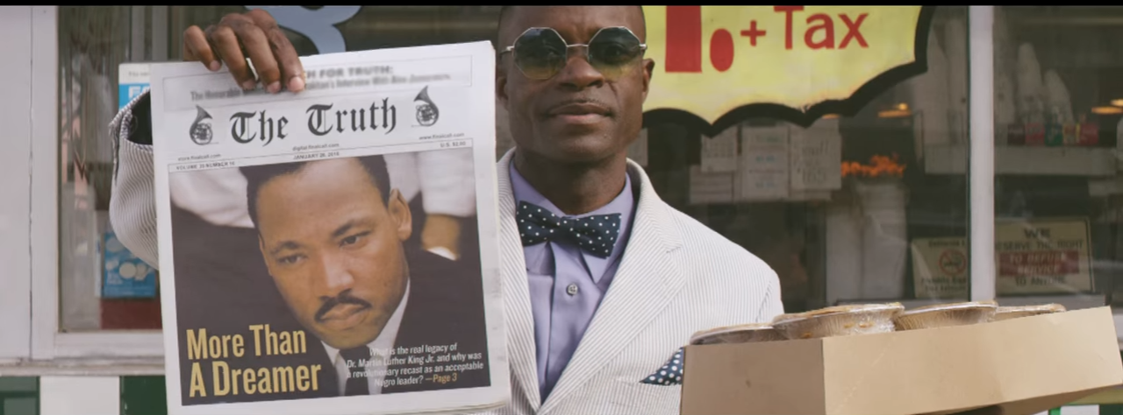 | 3.30  Depicts a man holding up a newspaper featuring Martin Luther King Jr | It depicts an African-American man demanding change through the use of throwbacks to different periods in time, with the reference to the famous speech. | The setting of the shot shows it outside a shop with references to taxes as well as the newspaper being the main focus of the shot. | There are representations of the black community in this music video with the newspaper being titled “The Truth”. | The audience would directly identify and recognise Martin Luther King Jr in the newspaper clipping showing that they too are capable of making change. |  | Martin Luther King Jr lead the 1955 civil rights movement from his famous speech ‘I have a dream’
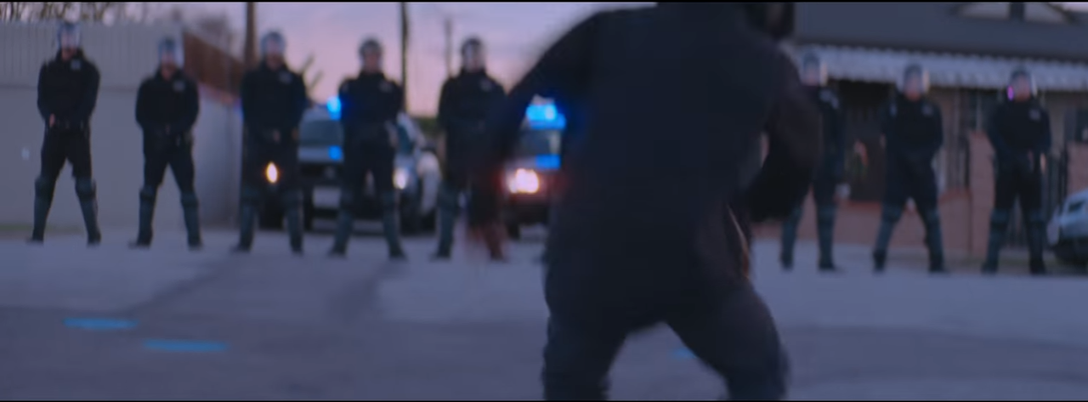 | . 3.42  A small child dancing in front of a row of police officers | Connotations to police brutality with the spray paint telling “Stop shooting us”, referencing these themes | The mise-en-scene includes shots of a young boy dancing in front of police officers with them surrendering. | The representations show the small boy making a difference by making the officers surrender, it also implies that no matter the age they can still make a difference. It also implies the Black Lives Matter campaign which was started with the death of Eric Garner. | The audience would see this and be surprised with the use of a child in links with police brutality. | The Black Lives Matter campaign which Beyonce and Jay Z both attended rallies to. | Black Lives Matter campaign

